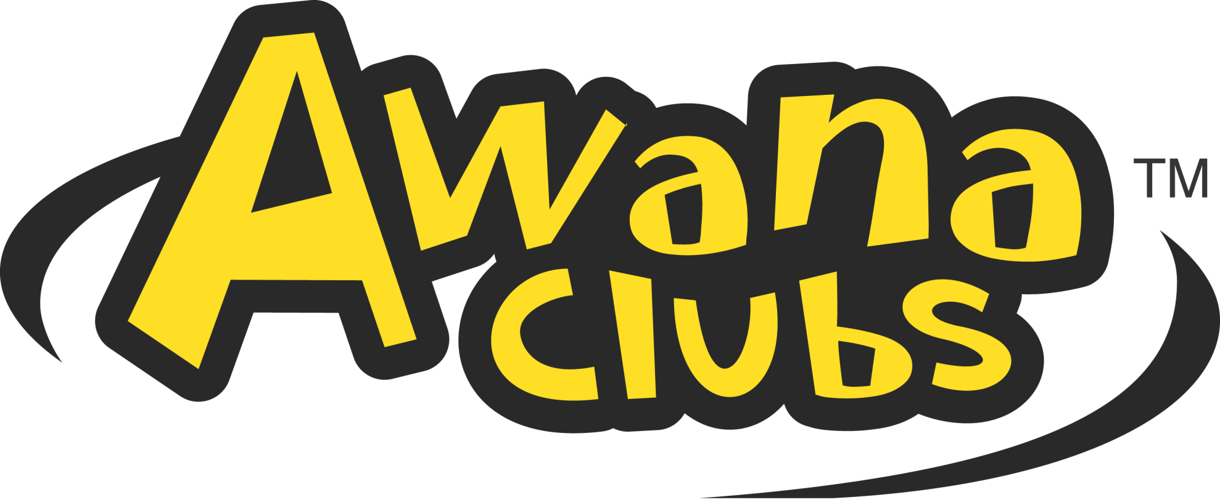
SHBC Office Use Only:
__ Contact List
__ B-Day List
__ Sign-In Sheet
__ Star Chart
__ Check-Out Sheet
__ Weekly Attendance
__ Star Poster
__ Remind.com
__ E-Mail
__ Nametag

Please return completed form to:
Surrey Hills Baptist Church
12421 N. Mustang Road
Yukon, OK 73099

Children’s Names:

_________________________________________________ B-day: _______________ Grade: ______

_________________________________________________ B-day: _______________ Grade: ______

_________________________________________________ B-day: _______________ Grade: ______

_________________________________________________ B-day: _______________ Grade: ______

_________________________________________________ B-day: _______________ Grade: ______

Parent and/or Guardian Name: ________________________________________________________

Address: ___________________________________________________________________________

E-Mail: ____________________________________________________________________________

Phone: _____________________________________________________________________________

Emergency Contact: _________________________________________________________________

Special Needs/Allergies: _______________________________________________________________

____________________________________________________________________________________

Member of what church: _____________________________________________________________

Who can pick up your child from AWANA? Your child will only be released to those individuals listed below. A note will be required in order for your child to be released with someone who is not on this list:

__________________________________________________________________________________________



